# Task 2b: GIS Analysis and Geoprocessing of Fire Danger Value in Buderim

## Abstract (strictly within 100 words)

Task2b sought to delve into the impact of streams, roads, and vegetation within Buderim on fire danger. The investigation revealed that Buderim exhibits a notably low fire danger, primarily attributed to its abundance of streams, roads, and lush rainforest vegetation. Consequently, the study highlights Buderim's rainforest setting as a significant factor contributing to its low fire risk compared to other regions in South East Queensland (SEQ). This underscores the need for relatively less attention towards fire hazard mitigation in Buderim, owing to its unique environmental characteristics.

## Introduction (~350 words)

Geographic Information Science (GIS) serves as a crucial tool for understanding and addressing real-world issues, particularly in assessing and mitigating risks such as fire hazards. By integrating location data with descriptive information, GIS enables a comprehensive analysis of spatial variables that contribute to such risks (Maguire, 1991). In the case of Buderim, a region facing potential fire dangers, GIS analysis was employed to examine key factors such as vegetation density, stream locations, and road networks within its boundaries. The decision to utilize GIS analysis in studying fire hazards in Buderim was rooted in its capacity to provide precise insights into how these variables influence the likelihood and severity of fire incidents. Traditional methods may lack the spatial granularity necessary to capture the intricate relationships between these factors and fire danger. By leveraging GIS, analysts can employ deterministic functions such as spatial queries, slope analysis, and exploratory analysis to discern patterns and correlations that inform risk assessment and mitigation strategies (Unwin, 1996).

GIS analysis proved effective in addressing the identified issue by offering a systematic approach to understanding the spatial distribution of fire hazards in Buderim. According to (Aspectrum, 2021) through suitability analysis and exploratory analysis, it was possible to manipulate large datasets to uncover critical insights into the factors contributing to fire risks. Without GIS analysis, comprehending the nuanced interplay between variables and their impact on fire danger would have been challenging, if not impossible. Moreover, GIS analysis facilitated a deeper understanding of the characteristics of Buderim and the relationships between its environmental features, such as streams, roads, and vegetation (Esri, 2024). This knowledge was instrumental in devising targeted interventions and land management strategies to mitigate fire hazards effectively (Okunuki, 2001).

In essence, GIS analysis provided a robust framework for assessing and addressing fire dangers in Buderim by harnessing spatial data and analytical techniques. By illuminating the spatial dynamics of risk factors, GIS empowered decision-makers with the information needed to implement proactive measures and safeguard the community against potential fire incidents. Without the utilization of GIS analysis and the ability to interpret the data effectively, the insights gained from investigating the study area's trends and patterns would have been of minimal value.

## Methods (~600 words)

### A map of the state of australia Description automatically generatedStudy area

Figure 1: Chosen Study Area, Torin Flanagan - ENS 253 Task 2b – 29/05/2024

The study area selected for analysis was Buderim, expanded from the previous focus on North Buderim in Task 2a due to its greater relevance. Figure 1 illustrates Buderim's location within the Sunshine Coast, with an inset highlighting the Queensland border. This choice was influenced by personal proximity, residing in Buderim, and the area's unique composition as primarily rainforest, making it intriguing for fire hazard analysis (Richer et al., 2023). The map includes essential cartographic elements such as a north arrow, scales (0 – 80 km and 0 – 2,000 km), legend, title, textual information, and the UniSC logo. These features ensure the map's clarity and accessibility for all users.

### Datasets

* Provide a list of datasets in Table 1 that you have collected or created for performing geoprocessing. Consider the feedback provided on the Task2a.
* Below is the dataset list used for the geoprocessing in the final Buderim fire hazard map. These datasets were pivotal in identifying the areas of highest and lowest fire susceptibility, incorporating streams, roads, and vegetation data.
* Data descriptions are succinct, focusing solely on location and content. For instance, "Sunshine Coast suburb boundaries" delineates each suburb's borders within the region.
* With Humboldt State University (2014) elucidating data models as means to represent real-world entities in GIS, the chosen data models were exclusively vector-based, comprising points, lines, or polygons. However, post-GIS analysis, outputs transitioned to raster-based models for pixelated or grid data.
* All datasets were sourced from the student G drive library, ensuring relevance to the study area. The data path utilized was Desktop > STUDENTG (\\usc.internal\usc\general) (G:) > Science_Health_Education > ENS253 > Data_sets.
* Coordinate systems were uniformly projected for consistency, with GDA 2020 chosen as the datum type for the feature dataset. Notably, GIS analyses were conducted using GDA 2020 MGA Zone 56. Map scales varied per dataset, ranging from 1:2,507,542 to 1:269,245.

|  |  |  |  |  |  |  |  |
| --- | --- | --- | --- | --- | --- | --- | --- |
|  | **Datasets description** | **Data model types** | **The data type (Primary or secondary)** | **Coordinate system (Geographic or projected)** | **Datum** | **Appropriate map-scale** | **Data source** |
|  | Suburb boundaries of the Sunshine Coast. | Vector, | Secondary | Projected | GDA 2020 | 1 : 2, 507, 542 | STUDENTG (\\usc.internal\usc\general) (G:) |
|  | Sunshine Coast road networks. | Vector | Secondary | Projected | GDA 2020 | 1 : 657, 337 | STUDENTG (\\usc.internal\usc\general) (G:) |
|  | Sunshine Coast streams networks. | Vector | Secondary | Projected | GDA 2020 | 1 : 269, 245 | STUDENTG (\\usc.internal\usc\general) (G:) |
|  | Vegetation density of the Sunshine Coast. | Vector | Secondary | Projected | GDA 2020 | 1 : 500, 000 | STUDENTG (\\usc.internal\usc\general) (G:) |

Table 1: Data Set Table, Torin Flanagan - ENS 253 Task 2b – 29/05/2024

### GIS analysis

During the process of GIS analysis, an application is supplied with the required input data where then the GIS analysis operations as seen in the table below are executed on a computing infrastructure (in this case ArcGIS Pro) to then display the results provided to the user (Hofer, 2014). Below are descriptions of the GIS analyses steps involved along with each geoprocessing tool used:

1. Create Feature Dataset: It creates a feature dataset in an output location (being an existing enterprise, file, or mobile geodatabase). Featured datasets are a collection of related feature classes that share the same coordinate system (GDA 2020 MGA Zone 56) and used to organise these related feature classes into a common container (Esri, 2024).
2. Export Features: Converts a feature class or feature layer into a new feature class. The Field Map parameter in Export Features manages fields and their content in the output dataset by adding/removing fields, reordering, renaming, changing data types, and more (Esri, 2024).
3. Select Layer By Attribute: Adds, updates, or removes a selection based on the attribute query. This tool creates a new layer with the applied operation, considering any present definition query for a feature class along with many more operations (Esri, 2024).
4. Export Features: It uses the field map parameter to manage the fields and the content in the output dataset. Fields can be added, removed, reordered, and renamed, with the output field’s default data type matching the first input field encountered, and various more actions (Esri, 2024).
5. Select Layer By Location: It selects features based on their spatial relationship to features in another dataset. The Selecting Features parameter evaluates each feature in the Input Features parameter, selecting it if the specified Relationship parameter value is met (Esri, 2024).
6. Euclidean Distance: It calculates the Euclidean distance to the closest source for each cell, this tool processes either a feature class or raster input data, converting these features to raster internally for analysis (Esri, 2024).

|  |  |
| --- | --- |
| **Location:** | **GIS Analysis:** |
| Data Management Tools | Create Feature Dataset |
| Conversion Tools | Export Features |
| Data Management Tools | Select Layer By Attribute |
| Conversion Tools | Export Features |
| Data Management Tools | Select Layer By Location |
| Spatial Analyst Tools | Euclidean Distance |

Table 2: GIS Analysis Table, Torin Flanagan – ENS 253 Task 2b – 29/05/2024

## A map of a country Description automatically generatedResults (~350 words)

Figure 2: Intermediate Map Of Fire Danger Variables, Torin Flanagan - ENS 253 Task 2b – 29/05/2024

Figure 2 displays the selected variables for assessing fire danger in the Buderim area scope. The inset provides context for Buderim's location within the broader Sunshine Coast region in Queensland, highlighting its position within the local area. The red outline delineates the Buderim area border, while yellow intertwining lines represent roads, blue lines depict streams, and bright green patches indicate vegetation. It's noteworthy that some streams and vegetation extend beyond the Buderim border, where these outside inclusions still largely influence the area's fire risk.

Upon locating and visualising these variables within the Buderim area, it became evident that the fire danger risk was primarily low rather than high. These variables are significant contributors to many fires nationwide. Deep insights, aided by research such as that by (Sturtevant & Cleland, 2007), into fire danger in Buderim are crucial for improving preparedness and effectiveness of fire spread and suppression efforts, thereby mitigating future occurrences.

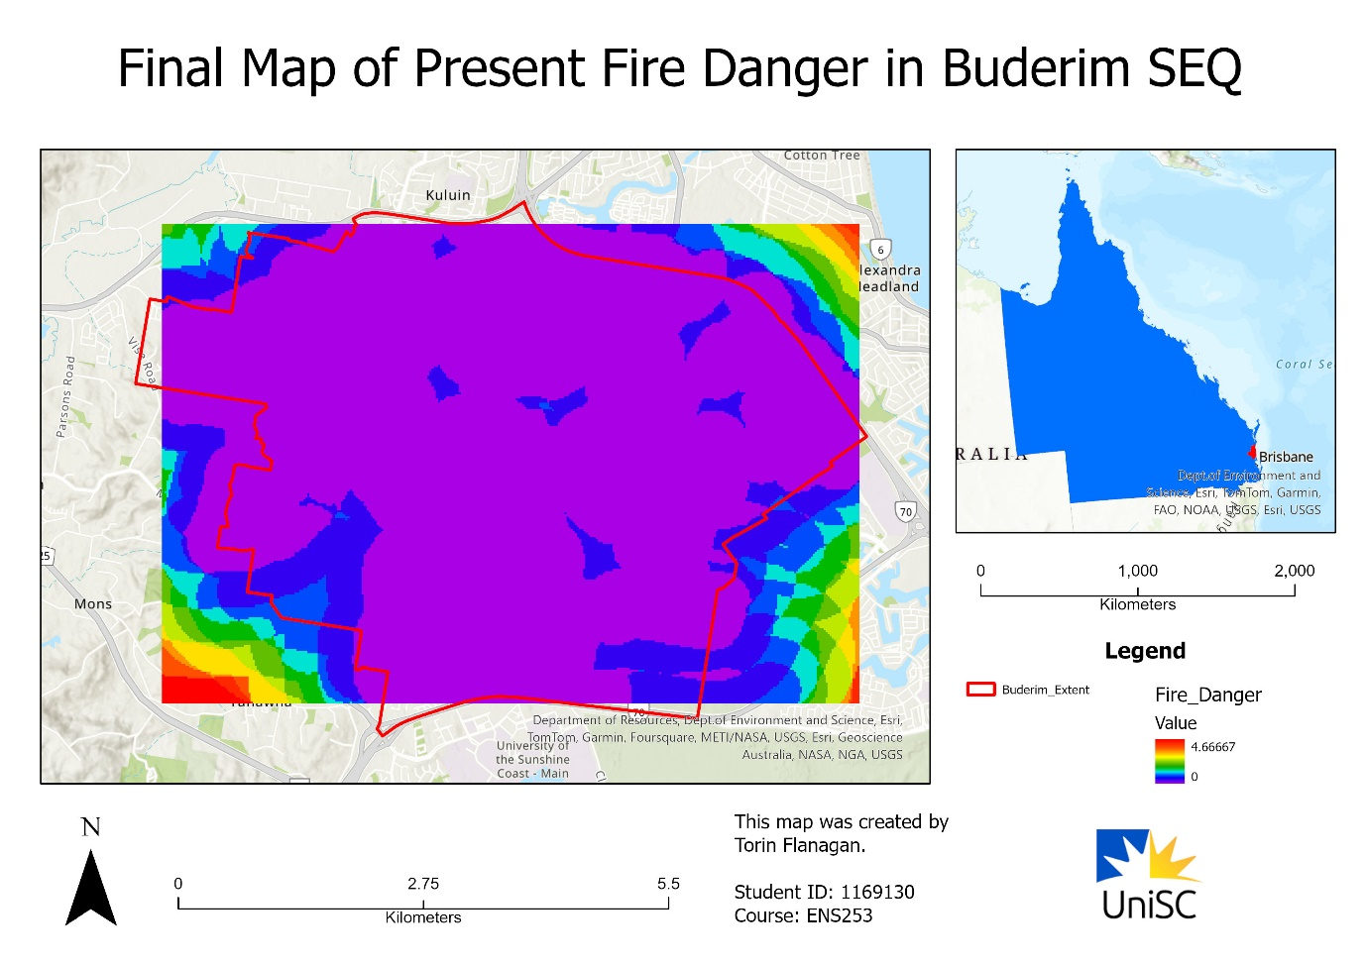Figure 3: Final Map Of Fire Danger Variables Inside Buderim, Torin Flanagan – ENS 253 Task 2b – 29/05/2024

Figure 3 extends the analysis from Figure 2 using additional GIS tools detailed in Table 2, revealing that the fire danger risk in Buderim is relatively low compared to other areas in the Sunshine Coast. Within the Buderim boundary, indicated by purple and blue areas denoting values close to zero, as shown on the legend, the fire danger is notably low. However, outside the Buderim boundary, the risk gradually increases, reaching up to 4.6* represented by red, as indicated on the legend.

Buderim's low fire danger values stem primarily from its classification as a rainforest, benefiting from higher annual rainfall compared to other regions in the Sunshine Coast. However, given the frequent weather fluctuations from South East Queensland (SEQ) in recent years, fire risks are increasingly evident, influenced by changing climates and government policies. This environmental dynamism, as noted by (Lorraine, 2023), underscores the variability in fire danger values for Buderim. While Figure 3 illustrates the current low risk due to the rainforest, external research highlights their susceptibility to change, emphasizing the need for ongoing monitoring and adaptation.

## Discussions (~300 words)

GIS analysis and geoprocessing tools revealed that Buderim's susceptibility to fire hazards, including roads, streams, and vegetation, was less significant than initially anticipated. These tools, such as Create Feature Dataset, Export Features, Select Layer By Attribute, Select Layer By Location, and Euclidean Distance, helped address this issue by providing insights into Buderim's low fire danger, attributed largely to its rainforest classification.

The streams dataset revealed numerous streams within Buderim, reinforcing the low fire danger assessment. Similarly, although the roads dataset is not directly correlated with the Buderim rainforest, it contributes to the low fire danger by impeding fire spread. Lastly, exploration of the vegetation dataset indicated that a significant portion, if not the majority, consisted of rainforest vegetation, further substantiating the rationale behind Buderim's low fire danger assessment.

To enhance the Buderim fire danger score dataset, incorporating contrasting variables that elevate rather than mitigate fire risk would yield more comprehensive results. These opposing variables, such as wind direction and speed, relative humidity, and topography, notably slopes intensifying fire spread (Northern Territory Government, 2023), would provide insights into factors exacerbating fire hazards. By including these opposing variables, the dataset would reflect not only variables minimizing fire risk but also those amplifying it, thereby offering a holistic assessment of threats to Buderim.

Constraints encountered during the creation of Figure 3 included data precision limitations regarding its alignment with the Buderim boundary, expansion of the vegetation dataset beyond this boundary, and the age of the datasets, dating back to 2020. Data precision within the Buderim boundary was compromised as fire danger values were based on variables within Buderim rather than precisely on its border. The vegetation dataset's extensive coverage beyond the boundary necessitated individual delineation of Buderim-related vegetation types. Additionally, while the datasets provided accurate information, their age, originating from 2020, now spans four years.

## Conclusions (~300 words)

Mentioning the achievements of your project and describe the importance of GIS analysis for addressing real-world issues. Furthermore, describe the difference between the Task2a (your imagination with GIS analysis) and the final Task2b (what actually you achieve).

One of the project's significant accomplishments was the identification of Buderim's comparatively low fire danger score concerning streams, roads, and vegetation, indicating its minimal fire risk due to its rainforest environment. Further investigation into the reasons behind Buderim's low fire danger revealed its rainforest classification as the primary factor, supported by external research. The GIS analysis process for addressing real-world issues involved both obtaining new data and utilizing existing datasets, with meticulous attention to data sources, collection methods, and analysis techniques, as emphasized by (Green & Ray, 2005).

Although Task2a sparked broader possibilities for GIS analysis compared to the more simplified outcome of Task2b, the resulting dataset remains accurate and relevant. The disparity between the two tasks can be attributed to project timelines, practical limitations, and the necessity for maintaining dataset accuracy. Despite their differences, both tasks focused on identifying fire-prone areas in South East Queensland (SEQ), albeit with Task2a encompassing North Buderim within SEQ, unlike Task2b. While Task2a initially aimed for four distinct map products, only one—comprising a fire hazard map spanning from North Buderim to the entire Buderim region—was feasible within the constraints of Task2b.

While Task2a laid the required groundwork for expansive GIS analysis possibilities, Task2b resulted in a more streamlined outcome which focused primarily on practical feasibility including dataset accuracy. Despite this shift in scope, the dataset created remained rather robust, aligning with the Task2b project requirements and objectives. The consolidation of findings from both Task2a and Task2b contributed to a more in-depth analysis of fire risk dynamics located inside the Buderim boundaries, underscoring the importance of context-driven GIS analysis addressing real-world challenges.

## Word counts (without references and Annexure) = 2, 062 words (excluding Abstract)

## References

* Aspectrum. (2021). Spatial Data Analysis In GIS. Aspectum; Earth Observing System. https://aspectum.com/spatial-analysis-techniques-and-their-use-in-business/
* Esri. (2024). Spatial Analysis In ArcGIS Pro—ArcGIS Pro | Documentation. Pro.arcgis.com. https://pro.arcgis.com/en/pro-app/latest/help/analysis/introduction/spatial-analysis-in-arcgis-pro.htm
* Green, D. R., & Ray, S. T. (2005). Using GIS For Siting Artificial Reefs - Data Issues, Problems And Solutions: “Real World” To “Real World.” Kluwer Academic Publishers EBooks, 37(1), 113–131. https://doi.org/10.1007/0-306-48002-6_9
* Hofer, B. (2014). Uses Of Online Geoprocessing Technology In Analyses And Case Studies: A Systematic Analysis Of Literature. International Journal of Digital Earth, 8(11), 901–917. https://doi.org/10.1080/17538947.2014.962632
* Humboldt State University. (2014). GSP 270: Data Models. Humboldt.edu. https://gsp.humboldt.edu/olm/Lessons/GIS/04%20CreatingSpatialData/VectorDataModels1.html
* Lorraine, S. (2023). Investigating Bushfire Risk On The Sunshine Coast Of South East Queensland. In research.usc.edu.au (p. 158). University of the Sunshine Coast, Queensland; research.usc.edu.au. https://doi.org/10.25907/00779
* Maguire, D. J. (1991). Overview And Definitions Of GIS http://lidecc.cs.uns.edu.ar/~nbb/ccm/downloads/Literatura/OVERVIEW% 0AND%20DEFINITION%20OF%20GIS.pdf
* Northern Territory Government. (2023, September 11). Factors That Create Bushfire Risk. Nt.gov.au. https://nt.gov.au/emergency/bushfire/factors-that-create-bushfire-risk
* Okunuki, K. (2001). Urban Analysis With GIS. GeoJournal, 52(1), 9. Springer.com.
* Richer, A., Shimizu, Y., Hansen, A., George, A., Shapcott, A., & Bowerman, E. (2023). The Success Of The Endangered Rainforest Shrub Graptophyllum Reticulatum (Buderim Holly, Veiny Graptophyllum) Acanthaceae, Translocation, 20 Years Later. Australasian Plant Conservation, 32(2). Informit.org.
* Sturtevant, B. R., & Cleland, D. T. (2007). Human And Biophysical Factors Influencing Modern Fire Disturbance In Northern Wisconsin. International Journal of Wildland Fire, 16(4), 398. publish.csiro.au. https://doi.org/10.1071/wf06023
* Unwin, D. J. (1996). GIS, Spatial Analysis And Spatial Statistics. Progress in Human Geography, 20(4), 540–551. https://doi.org/10.1177/030913259602000408

## Annexure

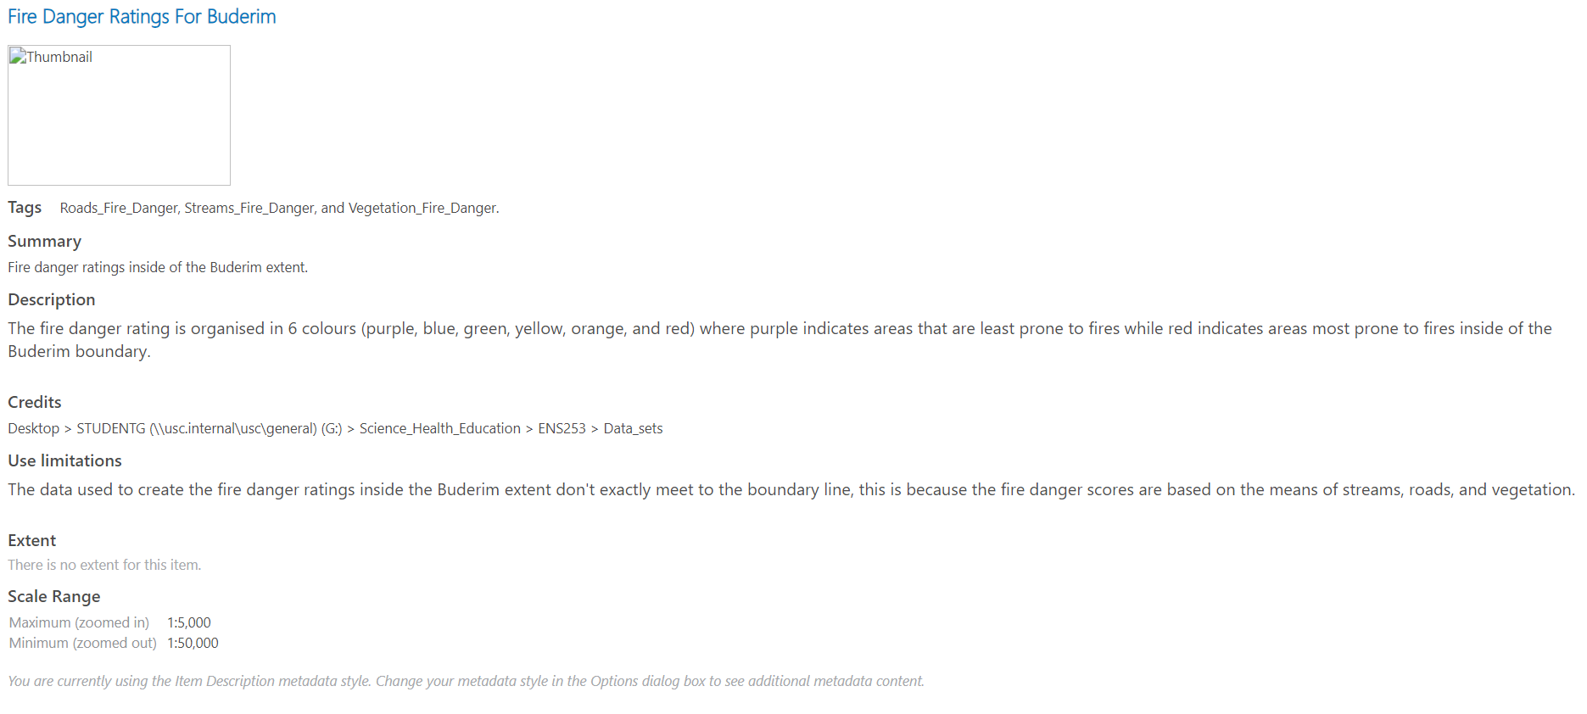<https://d.docs.live.net/1bb1864b7ca1ef51/2024%20Semester%201%20Files/Backup%20folders/Geographic%20Information%20Science%20and%20Technology/Metadata%20For%20Final%20Map.html>

**For instructors use only, please do not write anything below this**

Marking table (Do not remove this, and ensure that the table is not converted to an image)

